**Sponsorship Information**

We appreciate your time to consider sponsoring SQLSaturday Baton Rouge ! We’ve put together some information that will tell you about our plans for the event. There are multiple sponsorship opportunities for your company to maximize your 2025 SQLSaturday presence to hundreds of local IT professionals.

This year our event is July 26, 2025, on the campus of Louisiana State University at the Business Education Complex on Nicholson Extension.

**More Information:** sqlsatbr.com  
 **Email:** [sqlpassbr@gmail.com](mailto:sqlpassbr@gmail.com)

# Event Overview

Think of a SQLSaturday as a one-day free conference, linked to a network of similar conferences **around the world**. Tens of thousands of people register for SQLSaturday events worldwide each year. To read more about SQLSaturday conferences around the world, visit **sqlsaturday.com**.

We have raised and donated thousands of dollars to the Foundation for the East Baton Rouge Parish School System during our recent events, giving context and community impact to our event. Since 2018 we have also hosted a kid’s STEM track for 4th-8th graders, allowing parents and their kids to share an exciting day of learning together on campus.

We attract intelligent, volunteer, expert speakers from around the United States, provide free lunch on site, and we have a dedicated exhibitor area set up for our attendees to meet with our sponsors. We work diligently to make our event a great experience for everyone, especially our sponsors who enable us to cover the working costs of this event. Our event is open to the public, especially for students, job seekers, and folks in career transition, but also for seasoned professionals, IT veterans, and fellow experts.

The event is attended by SQL Server engineers, developers, managers, and other IT professionals who attend topics of a wide range of technologies and soft skills. There will be high-quality technical sessions on not just **SQL Server**, but also **.NET, mobile app, business intelligence, Windows Server, PowerShell, analytics, IT leadership** and more. This year is our 13th annual SQLSaturday Baton Rouge, and each year we’ve drawn upwards of 600 to the **LSU campus.**

**Consider SQLSaturday Baton Rouge your one-stop shop for recruiting, corporate marketing, IT staff training and continuing education.**

**Who Attends SQLSaturday Baton Rouge?**

Folks with the following skillsets are drawn to SQLSaturday Baton Rouge because of the professional networking, free training, and giveaways:

* SQL Server Administrators
* Business Intelligence Developers
* Data Analysts
* ETL Developers
* C#/VB.NET Developers
* Mobile Developers
* Windows Server Admins
* SharePoint Architects
* SharePoint Developers
* Network Administrators
* Quality Assurance Analysts
* IT Managers and CIO’s
* Project Managers
* Students

**What is the Return on Investment for sponsors?**

After our 2019 event, we polled attendees with this question and got these real answers:

# As an attendee, what do you feel is the Return on Investment for sponsors?

# 

* “The attendees for SQLSaturday are generally the **tech influencers in the area**. These people will often guide decisions on the purchase or use of tech-based products. If I were a company in that field, I would certainly have this event in mind every time I work on an advertising budget.”
* “For the vendors it is the **best platform to exhibit their products and get exposure** to the professional working with top companies.”
* “There is a pool of intelligent people that want to stay current on technology and are motivated to learn from and/or teach peers. If they have the right offer for jobs there is talent to fill it.”
* “Being acknowledged as a sponsor for an event that helps the community gives them a great representation of giving back.”
* “There was a lot of brand recognition. I felt that the sponsors got **a lot of facetime with the attendees.**”
* “I've certainly biased purchasing decisions toward sponsors based solely on sponsorship before (for equivalent products). I also likely wouldn't know who most of them are without their sponsorship.”
* They get **up-close access** to the entire Baton Rouge IT market. It gives them access to hire the best and brightest and/or sell their services to this group.
* “For what seems like a "small" event is actually rather large and has **quite a lot of foot traffic**.”

# What Sponsorship Opportunities Are Available?

We offer a wide variety of sponsorship packages, which enable us to provide the one-day educational conference free to attendees. That’s right – unlike similar events, SQLSaturday Baton Rouge is completely free to attend – attendees receive lunch, cold drinks, snacks or goodie bags all free of charge.

No pre-registration is required, though encouraged. The event is open to the public.

A quick breakdown of our 2025 sponsorship levels.

* Blog Sponsorship - $25
* Bronze Sponsorship - $100
* Silver Sponsorship - $500
* Unattended Booth - $1000
* Gold Sponsorship - $1500
* Platinum Sponsorship - $2500

|  |  |  |  |  |  |  |
| --- | --- | --- | --- | --- | --- | --- |
|  | **Logo on Website** | **Your Swag in 600 Bags** | **Attendee Contact List (Excel format)** | **Banquet**  **Invitations** | **Exclusive**  **Presence**  **Options** | **Email Blast to Opted-In Attendees** |
| **Blog** | **Yes** | **No** | **No** | **No** | **No** | **No** |
| **Bronze** | **Yes** | **Yes** | **No** | **No** | **No** | **No** |
| **Silver** | **Yes** | **Yes** | **No** | **No** | **No** | **No** |
| **Unattended Booth** | **Yes** | **Yes** | **Yes** | **No** | **No** | **No** |
| **Gold** | **Yes** | **Yes** | **Yes** | **Yes** | **No** | **No** |
| **Platinum** | **Yes** | **Yes** | **Yes** | **Yes** | **Yes** | **Yes (x2)** |

|  |  |  |  |  |
| --- | --- | --- | --- | --- |
|  | **Raffle Ticket for**  **Day-End Raffle** | **Small Booth Space** | **Large Booth**  **Space** | **The Premium Booth Space** |
| **Blog** | **No** | **No** | **No** | **No** |
| **Bronze** | **No** | **No** | **No** | **No** |
| **Silver** | **Yes** | **Yes** | **No** | **No** |
| **Unattended Booth** | **Yes** | **No** | **No** | **No** |
| **Gold** | **Yes** | **No** | **Yes** | **No** |
| **Platinum** | **Yes** | **No** | **Yes** | **Available** |

Booths are reserved for sponsors at time of payment on a first come, first serve basis. We have limited booth space and have had to turn away last-minute sponsors the last 2 years!

**SQLSaturday Baton Rouge Sponsorship Levels**

**Book Sponsor.** Free

* Want your books included in our Book Library and Day-end Raffle? Send them to us, your target audience will find them here!

**Blog Sponsorship.** $25 prepaid.

* Your linked image, and contact info on the SQLSaturday Baton Rouge 2025 website. Thanks!

**Bronze Sponsorship.** $100 prepaid.

* Your corporate image/logo on the conference brochure
* Any of materials (pens, fliers, gadgets, swag) inserted into all 600 conference bags.
* Your linked image, and contact info on the SQLSaturday Baton Rouge 2025 website.

**Silver Sponsorship.** $500 prepaid.

* Bronze +
* Small Booth (only six available)
  + Your total space is roughly a 5’x5’ square.
  + Café-style round or square table, power, seating for two. You can decide whether to use the table or your own presentation foldout, though it must occupy the same footprint as the provided table. Height of conference banners should not be an issue.
* Participation in the raffle at the end of the conference
  + Briefly address all the conference attendees at the end of the conference and draw to give away a prize – all attention to you!

What would you do with your “booth zone”? In the past, a sponsor ditched the folding table and brought in a carpet, couch and espresso machine. Another had a fastest Lego kit building competition, or a code debugging contest, or a video game setup.

**Unattended Booth Sponsorship.** $1000 prepaid. (Six available.)

Can’t join us in person in Baton Rouge? We can still get your logo and materials in front of foot traffic! Mail us your fliers, giveaways, tabletop sign, etc.! We’ll arrange the unmanned Booth Sponsors together to fit.

* Bronze +
* A contact list of the pre-registrations for the conference, with attendee contact information, for registrants who opted in to being contacted by sponsors. (Usually a Gold-level benefit!)
* Participation in the raffle at the end of the conference with a prize that can be awarded using the conference’s raffle tickets is optional.

**Gold Sponsorship.** $1500 prepaid.

* Silver +

There are four major advantages for Gold over the Silver package:

* Larger Booth (only seven available)
  + Instead of a smaller round table, an 8’ long rectangular table, power, seating for two. Your total space is roughly an 8’x5’ rectangle.
  + You can decide whether to use the table or your own presentation foldout or furniture, though it must occupy the same footprint as the provided table.
  + The height of conference banners should not be an issue.
* A contact list of the pre-registrations for the conference, with attendee contact information, for registrants who opted in to being contacted by sponsors. Not available to Silver.
* Up to four tickets to the pre-conference banquet on Friday August 5th.
  + The Banquet will be “sponsored” by a single Platinum-level sponsor, see below.

**Special Note: Because of LSU policy, no food or drink is allowed in the classrooms. Since 2015, we have been unable to offer the opportunity to present sessions during the lunch break.**

**Platinum Sponsorships.** $2500 prepaid for each unique sponsorship.

* Gold +
* Each Platinum Sponsorship is a different exclusive sponsorship customized for each company.
* We are open to any creative one-of-a-kind sponsorship ideas exclusive to Platinum.
* In the past, each Platinum sponsor has put their creative folks to work to make a lasting impression on attendees at our conference!
* In the past we have had a lot of success and ROI for sponsors by working with them to creatively and exclusively come up with their own ideas that capitalize on each Platinum sponsor’s strengths and onsite staff.
* Platinum sponsors can have up to two email blasts sent to all opted-in attendees. This is an excellent way to get your message out to even those folks that don’t make it on Saturday to see your booth in person! You simply provide us with your message, and we’ll send it out!
* Ideas on the next page à

**Get your company’s creative minds together and see the below Platinum ideas:**

* **Platinum Pre-Conference Banquet Sponsorship -** (Only one available)
  + A vendor booth at the Gold level, plus:
  + Sponsor the annual pre-conference banquet. Use our traditional location near LSU campus in Baton Rouge or pick your own venue. We usually attract 70-80 folks to the event, most of which are the conference’s out of town expert speakers and community volunteers.
  + The banquet is open to all speakers and Gold+ sponsors to attend, many of which fly in from around the country to speak at our event.
    - Unlimited tickets for your corporate personnel to attend.
    - Microphone time to address the banquet. We can discuss presentation aids if necessary.
    - A night of face time with the top-end tech speakers from around the country!
* **Platinum “Big Booth” Prime Vendor Floor Space -** (Only one available)
  + The largest booth size plus prime position vendor booth in the atrium.
    - Roughly 12’x12’ square of floor space, much larger than other spaces.
    - Make the biggest impression in the booth area – giant-sized tailgate tent optional!
    - All other vendors will receive a single 8’ long or round table.
    - In years past, this vendor has brought a ceiling-height booth foldout display. Power and ample floor space will be available to all booths.
* **Breakfast, Lunch and Snack Sponsor -** (Only one available)
  + A vendor booth at the Gold level, plus:
  + Sponsor the conference dining area: exclusive signage and materials at the breakfast, coffee, lunch and snacks area.
  + Help us serve lunch while wearing your corporate gear!
  + Guaranteed face time with all 600+ attendees on the day of the conference!
  + Want to get creative with snacks? Let’s talk!
* **Platinum Creative (You tell us!)**
  + Gold +
  + Let’s discuss!

# The Raffle – Your Key to Success!

We provide the raffle box and will have blank cards available for attendees to fill in their information. We will have one table for all absentee vendors placed in the same areas with our onsite vendors. Raffle ticket collection will proceed through the end of the day. If someone from your team is present, we’ll ask them to draw the winning ticket, otherwise we’ll draw the ticket. Attendees must be present to win. If there is a physical prize we’ll give it to them, otherwise we’ll forward you their contact information for you to follow up with (for license keys, etc.). 79% of our attendees stay all day until the final raffle!

After the event we will mail you all the raffle tickets from your box. There may be duplicates; depending on how exciting your prize is attendees may contribute more than one ticket to your box – but that’s a good thing, they are willing to provide you with their contact information in return for the chance to win.

# Payment

All fees must be paid in advance. Payment can be made through the SQL Saturday website via  
 **PayPal** (which can process a credit card) to [**sqlpassbr@gmail.com**](mailto:sqlpassbr@gmail.com)or **check.** Corporate checks are preferred and should be made out to “Baton Rouge User Groups”, the name of a not-for-profit corporation that helps operate many local Baton Rouge technical user groups (including .NET, SQL, Analytics, and more) in addition to the annual SQLSaturday events. BRUG can, upon request, provide an official invoice for expense purposes.

# Event Logistics

Registration for attendees opens at 8:00am, and the building should be open by 7am for booth setup. Vendors and sponsors should arrive no later than 7:30am. All sponsors with booths will be provided with a table and two chairs, and access to a power strip. Tables will be in the same area as registration and breakfast to make it easy for attendees to stop by your table.

Please emphasize to your corporate representatives on site at the event that they should remain on site through the end of the day, so they can personally greet the entire conference attendance in the Auditorium, be photographed and present any prize(s) to raffle winners. The final raffle usually is over by 4:30pm.

Lunch will be provided to all attendees including sponsor attendees. **All attendees from your corporation should register at SQLSaturday.com,** including **everyone** from your booth team. This is so that we can have enough food available at lunch.

Information about the SQLSaturday Pre-Conference Banquet will be made available soon.

# Mailing and Shipping Information

Payment, materials for 500 bags, and sponsor booth materials can all be mailed to:

Baton Rouge User Groups  
 9618 Jefferson Hwy   
Suite D Box 113   
Baton Rouge, LA 70809  
 (225) 755-9325

Sponsor **registration** and **payment deadline is July 7, 2025**. In the past we have sold out of booth space a month before the event. **Materials for bags MUST be delivered by July 14, 2025.** Email below for local delivery if desired.

Questions? Please contact the event committee at [SQLpassbr@gmail.com](mailto:SQLpassbr@gmail.com)

# Code of Conduct

**SQLSaturday Baton Rouge** is dedicated to providing a harassment-free conference experience for everyone, regardless of **gender, sexual orientation, disability, physical appearance, body size, race,** or **religion.** We do not tolerate harassment of conference participants in any form. This policy, in place since 2014, applies to speakers, staff, volunteers, sponsor and vendor personnel, booth teams and attendees.

In general, prohibited conduct includes any abusive conduct that has the purpose or effect of unreasonably interfering with another person’s ability to enjoy and participate in the conference, including social events related to the conference.

Remember that sexist, racist, ageist, religious, and other exclusionary jokes can be offensive to those around you and are inappropriate for SQLSaturday events. Excessive swearing and offensive jokes are not appropriate for SQLSaturday events.

Learners of all ages are welcome, but children's behavior should be consistent with the rest of the audience and should not be a distraction to presenters. Children should not roam the room and if playing with electronic toys, should play silently.

Persons who are the targets of, or witnesses to, hostile or harassing conduct should contact conference staff. Reports of hostile or harassing conduct will be promptly addressed. Attendees violating these rules may be asked to leave the conference at the sole discretion of the conference organizers.

**Be kind to others. Do not insult or put down other attendees. Behave professionally.**   
**Thank you for helping make this a welcoming, friendly event for all.**

* SQLSaturday Baton Rouge is an **alcohol-free** zone. We have zero tolerance for alcohol use during the event. Social events related to the conference may have a different policy.
* **Tobacco** use is regulated by existing state, city and Louisiana State University campus regulations and can be used in clearly marked areas. Smoking is **NOT** allowed in or near buildings.
* SQL Server Administrators
* Business Intelligence Developers
* Data Analysts
* ETL Developers
* C#/VB.NET Developers
* Mobile Developers
* Windows Server Admins
* SharePoint Architects
* SharePoint Developers
* Network Administrators
* Quality Assurance Analysts
* IT Managers and CIO’s
* Project Managers
* Students

**What is the Return on Investment for sponsors?**

After our 2019 event, we polled attendees with this question and got these real answers:

# As an attendee, what do you feel is the Return on Investment for sponsors?

* “The attendees for SQLSaturday are generally the **tech influencers in the area**. These people will often guide decisions on the purchase or use of tech-based products. If I were a company in that field, I would certainly have this event in mind every time I work on an advertising budget.”
* “For the vendors it is the **best platform to exhibit their products and get exposure** to the professional working with top companies.”
* “There is a pool of intelligent people that want to stay current on technology and are motivated to learn from and/or teach peers. If they have the right offer for jobs there is talent to fill it.”
* “Being acknowledged as a sponsor for an event that helps the community gives them a great representation of giving back.”
* “There was a lot of brand recognition. I felt that the sponsors got **a lot of facetime with the attendees.**”
* “I've certainly biased purchasing decisions toward sponsors based solely on sponsorship before (for equivalent products). I also likely wouldn't know who most of them are without their sponsorship.”
* They get **up-close access** to the entire Baton Rouge IT market. It gives them access to hire the best and brightest and/or sell their services to this group.
* “For what seems like a "small" event is actually rather large and has **quite a lot of foot traffic**.”

# What Sponsorship Opportunities Are Available?

We offer a wide variety of sponsorship packages, which enable us to provide the one-day educational conference free to attendees. That’s right – unlike similar events, SQLSaturday Baton Rouge is completely free to attend – attendees receive lunch, cold drinks, snacks or goodie bags all free of charge.

No pre-registration is required, though encouraged. The event is open to the public.

A quick breakdown of our 2025 sponsorship levels.

* Blog Sponsorship - $25
* Bronze Sponsorship - $100
* Silver Sponsorship - $500
* Unattended Booth - $1000
* Gold Sponsorship - $1500
* Platinum Sponsorship - $2500

|  |  |  |  |  |  |  |
| --- | --- | --- | --- | --- | --- | --- |
|  | Logo on Website | Your Swag in 600 Bags | Attendee Contact List (Excel format) | Banquet  Invitations | Exclusive  Presence Options | Email Blast to Opted-In Attendees |
| Blog | Yes | No | No | No | No | No |
| Bronze | Yes | Yes | No | No | No | No |
| Silver | Yes | Yes | No | No | No | No |
| Unattended Booth | Yes | Yes | Yes | No | No | No |
| Gold | Yes | Yes | Yes | Yes | No | No |
| Platinum | Yes | Yes | Yes | Yes | Yes | Yes (x2) |

|  |  |  |  |  |
| --- | --- | --- | --- | --- |
|  | Raffle Ticket for  Day-End Raffle | Small Booth Space | Large Booth  Space | The Premium Booth Space |
| Blog | No | No | No | No |
| Bronze | No | No | No | No |
| Silver | Yes | Yes | No | No |
| Unattended Booth | Yes | No | No | No |
| Gold | Yes | No | Yes | No |
| Platinum | Yes | No | Yes | Available |

Booths are reserved for sponsors at time of payment on a first come, first serve basis. We have limited booth space and have had to turn away last-minute sponsors the last 2 years!

SQLSaturday Baton Rouge Sponsorship Levels

**Book Sponsor.** Free

* Want your books included in our Book Library and Day-end Raffle? Send them to us, your target audience will find them here!

**Blog Sponsorship.** $25 prepaid.

* Your linked image, and contact info on the SQLSaturday Baton Rouge 2025 website. Thanks!

**Bronze Sponsorship.** $100 prepaid.

* Your corporate image/logo on the conference brochure
* Any of materials (pens, fliers, gadgets, swag) inserted into all 600 conference bags.
* Your linked image, and contact info on the SQLSaturday Baton Rouge 2025 website.

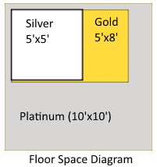**Silver Sponsorship.** $500 prepaid.

* Bronze +
* Small Booth (only six available)
  + Your total space is roughly a 5’x5’ square.
  + Café-style round or square table, power, seating for two. You can decide whether to use the table or your own presentation foldout, though it must occupy the same footprint as the provided table. Height of conference banners should not be an issue.
* Participation in the raffle at the end of the conference
  + Briefly address all the conference attendees at the end of the conference and draw to give away a prize – all attention to you!

What would you do with your “booth zone”? In the past, a sponsor ditched the folding table and brought in a carpet, couch and espresso machine. Another had a fastest Lego kit building competition, or a code debugging contest, or a video game setup.

**Unattended Booth Sponsorship.** $1000 prepaid. (Six available.)

Can’t join us in person in Baton Rouge? We can still get your logo and materials in front of foot traffic! Mail us your fliers, giveaways, tabletop sign, etc.! We’ll arrange the unmanned Booth Sponsors together to fit.

* Bronze +
* A contact list of the pre-registrations for the conference, with attendee contact information, for registrants who opted in to being contacted by sponsors. (Usually a Gold-level benefit!)
* Participation in the raffle at the end of the conference with a prize that can be awarded using the conference’s raffle tickets is optional.

**Gold Sponsorship.** $1500 prepaid.

* Silver +

There are four major advantages for Gold over the Silver package:

* Larger Booth (only seven available)
  + Instead of a smaller round table, an 8’ long rectangular table, power, seating for two. Your total space is roughly an 8’x5’ rectangle.
  + You can decide whether to use the table or your own presentation foldout or furniture, though it must occupy the same footprint as the provided table.
  + The height of conference banners should not be an issue.
* A contact list of the pre-registrations for the conference, with attendee contact information, for registrants who opted in to being contacted by sponsors. Not available to Silver.
* Up to four tickets to the pre-conference banquet on Friday July 25th.
  + The Banquet will be “sponsored” by a single Platinum-level sponsor, see below.

**Special Note: Because of LSU policy, no food or drink is allowed in the classrooms. Since 2015, we have been unable to offer the opportunity to present sessions during the lunch break.**

**Platinum Sponsorships.**$2500 prepaid for each unique sponsorship.

* Gold +
* Each Platinum Sponsorship is a different exclusive sponsorship customized for each company.
* We are open to any creative one-of-a-kind sponsorship ideas exclusive to Platinum.
* In the past, each Platinum sponsor has put their creative folks to work to make a lasting impression on attendees at our conference!
* In the past we have had a lot of success and ROI for sponsors by working with them to creatively and exclusively come up with their own ideas that capitalize on each Platinum sponsor’s strengths and onsite staff.
* Platinum sponsors can have up to two email blasts sent to all opted-in attendees. This is an excellent way to get your message out to even those folks that don’t make it on Saturday to see your booth in person! You simply provide us with your message, and we’ll send it out!
* Ideas on the next page à

**Get your company’s creative minds together and see the below Platinum ideas:**

* **Platinum Pre-Conference Banquet Sponsorship -** (Only one available)
  + A vendor booth at the Gold level, plus:
  + Sponsor the annual pre-conference banquet. Use our traditional location near LSU campus in Baton Rouge or pick your own venue. We usually attract 70-80 folks to the event, most of which are the conference’s out of town expert speakers and community volunteers.
  + The banquet is open to all speakers and Gold+ sponsors to attend, many of which fly in from around the country to speak at our event.
    - Unlimited tickets for your corporate personnel to attend.
    - Microphone time to address the banquet. We can discuss presentation aids if necessary.
    - A night of face time with the top-end tech speakers from around the country!
* **Platinum “Big Booth” Prime Vendor Floor Space -** (Only one available)
  + The largest booth size plus prime position vendor booth in the atrium.
    - Roughly 12’x12’ square of floor space, much larger than other spaces.
    - Make the biggest impression in the booth area – giant-sized tailgate tent optional!
    - All other vendors will receive a single 8’ long or round table.
    - In years past, this vendor has brought a ceiling-height booth foldout display. Power and ample floor space will be available to all booths.
* **Breakfast, Lunch and Snack Sponsor -** (Only one available)
  + A vendor booth at the Gold level, plus:
  + Sponsor the conference dining area: exclusive signage and materials at the breakfast, coffee, lunch and snacks area.
  + Help us serve lunch while wearing your corporate gear!
  + Guaranteed face time with all 600+ attendees on the day of the conference!
  + Want to get creative with snacks? Let’s talk!
* **Platinum Creative (You tell us!)**
  + Gold +
  + Let’s discuss!

# The Raffle – Your Key to Success!

We provide the raffle box and will have blank cards available for attendees to fill in their information. We will have one table for all absentee vendors placed in the same areas with our onsite vendors. Raffle ticket collection will proceed through the end of the day. If someone from your team is present, we’ll ask them to draw the winning ticket, otherwise we’ll draw the ticket. Attendees must be present to win. If there is a physical prize we’ll give it to them, otherwise we’ll forward you their contact information for you to follow up with (for license keys, etc.). 79% of our attendees stay all day until the final raffle!

After the event we will mail you all the raffle tickets from your box. There may be duplicates; depending on how exciting your prize is attendees may contribute more than one ticket to your box – but that’s a good thing, they are willing to provide you with their contact information in return for the chance to win.

# Payment

All fees must be paid in advance. Payment can be made through the SQL Saturday website via  
**PayPal** (which can process a credit card) to [**sqlpassbr@gmail.com**](mailto:sqlpassbr@gmail.com)or **check.** Corporate checks are preferred and should be made out to “Baton Rouge User Groups”, the name of a not-for-profit corporation that helps operate many local Baton Rouge technical user groups (including .NET, SQL, Analytics, and more) in addition to the annual SQLSaturday events. BRUG can, upon request, provide an official invoice for expense purposes.

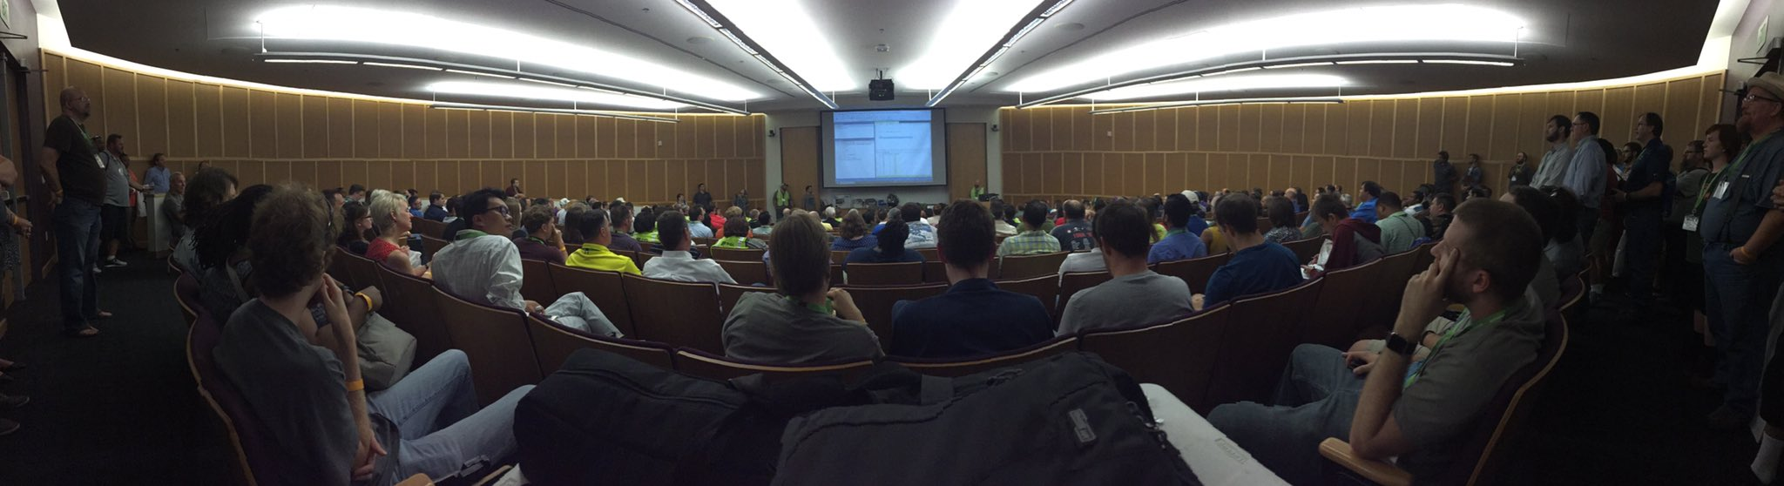

# Event Logistics

Registration for attendees opens at 8:00am, and the building should be open by 7am for booth setup. Vendors and sponsors should arrive no later than 7:30am. All sponsors with booths will be provided with a table and two chairs, and access to a power strip. Tables will be in the same area as registration and breakfast to make it easy for attendees to stop by your table.

Please emphasize to your corporate representatives on site at the event that they should remain on site through the end of the day, so they can personally greet the entire conference attendance in the Auditorium, be photographed and present any prize(s) to raffle winners. The final raffle usually is over by 4:30pm.

Lunch will be provided to all attendees including sponsor attendees. **All attendees from your corporation should register at SQLSaturday.com,** including **everyone** from your booth team. This is so that we can have enough food available at lunch.

Information about the SQLSaturday Pre-Conference Banquet will be made available soon.

# Mailing and Shipping Information

Payment, materials for 500 bags, and sponsor booth materials can all be mailed to:

Baton Rouge User Groups  
9618 Jefferson Hwy   
Suite D Box 113   
Baton Rouge, LA 70809  
(225) 755-9325

Sponsor **registration** and **payment deadline is July 9, 2025**. In the past we have sold out of booth space a month before the event. **Materials for bags MUST be delivered by July 14, 2025.** Email below for local delivery if desired.

Questions? Please contact the event committee at [SQLpassbr@gmail.com](mailto:SQLpassbr@gmail.com)

# Code of Conduct

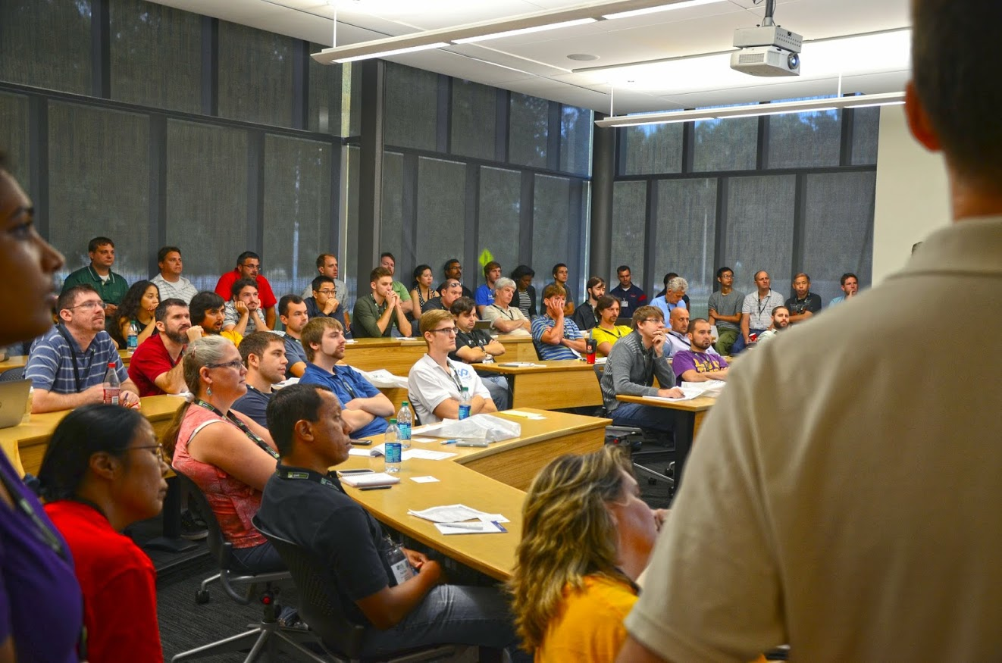

**SQLSaturday Baton Rouge** is dedicated to providing a harassment-free conference experience for everyone, regardless of **gender, sexual orientation, disability, physical appearance, body size, race,** or **religion.** We do not tolerate harassment of conference participants in any form. This policy, in place since 2014, applies to speakers, staff, volunteers, sponsor and vendor personnel, booth teams and attendees.

In general, prohibited conduct includes any abusive conduct that has the purpose or effect of unreasonably interfering with another person’s ability to enjoy and participate in the conference, including social events related to the conference.

Remember that sexist, racist, ageist, religious, and other exclusionary jokes can be offensive to those around you and are inappropriate for SQLSaturday events. Excessive swearing and offensive jokes are not appropriate for SQLSaturday events.

Learners of all ages are welcome, but children's behavior should be consistent with the rest of the audience and should not be a distraction to presenters. Children should not roam the room and if playing with electronic toys, should play silently.

Persons who are the targets of, or witnesses to, hostile or harassing conduct should contact conference staff. Reports of hostile or harassing conduct will be promptly addressed. Attendees violating these rules may be asked to leave the conference at the sole discretion of the conference organizers.

**Be kind to others. Do not insult or put down other attendees. Behave professionally.   
Thank you for helping make this a welcoming, friendly event for all.**

* SQLSaturday Baton Rouge is an **alcohol-free** zone. We have zero tolerance for alcohol use during the event. Social events related to the conference may have a different policy.
* **Tobacco** use is regulated by existing state, city and Louisiana State University campus regulations and can be used in clearly marked areas. Smoking is **NOT** allowed in or near buildings.